**Employee Management System**

1. Login Form with User as ADMIN having Role as ADMIN

UserName: ADMIN

Password: ADMIN

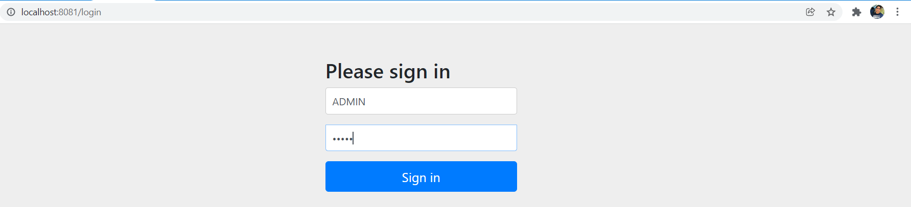

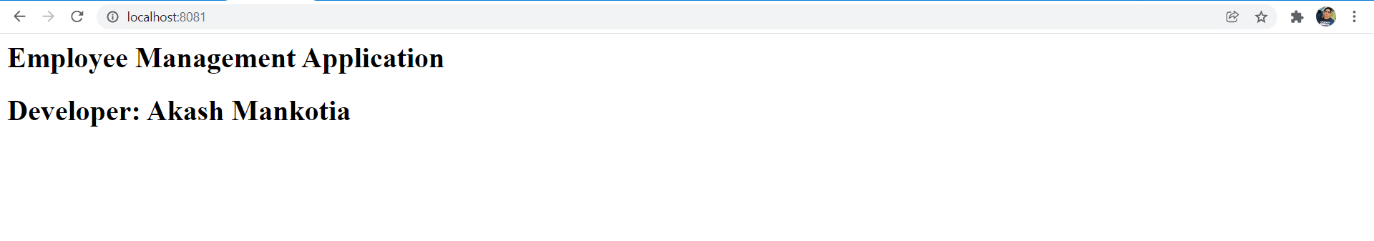

1. Performing Below Operations from PostMan
2. **Adding 5 Employees**

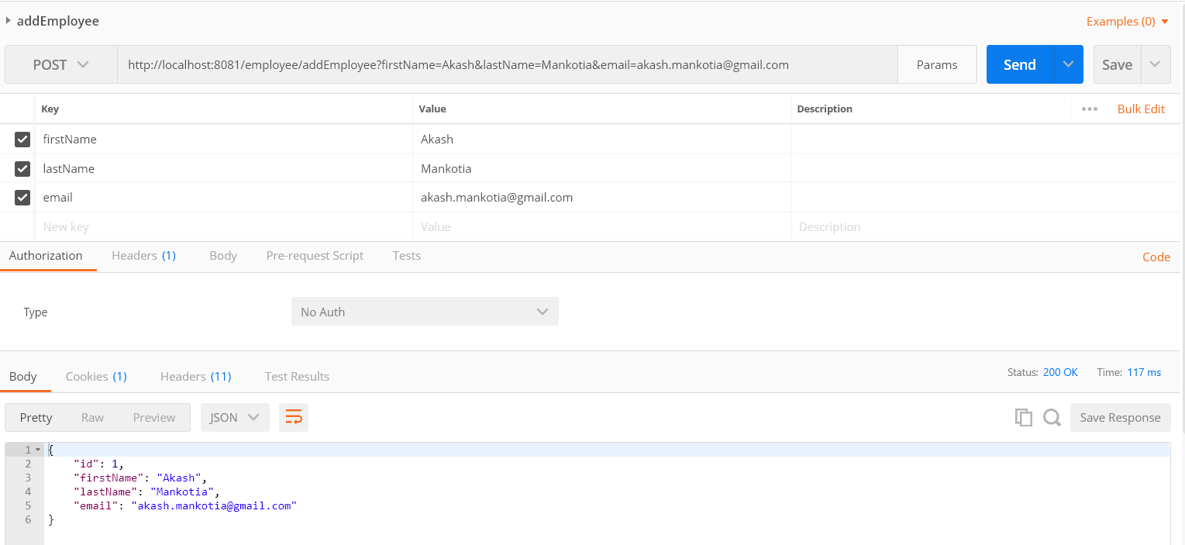

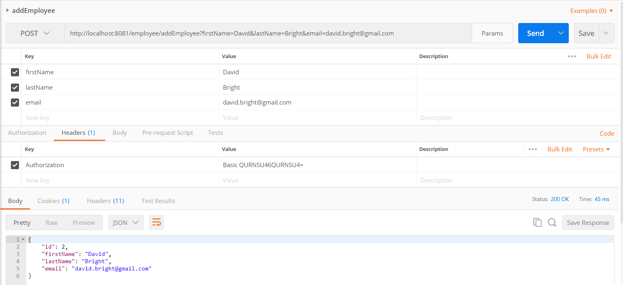

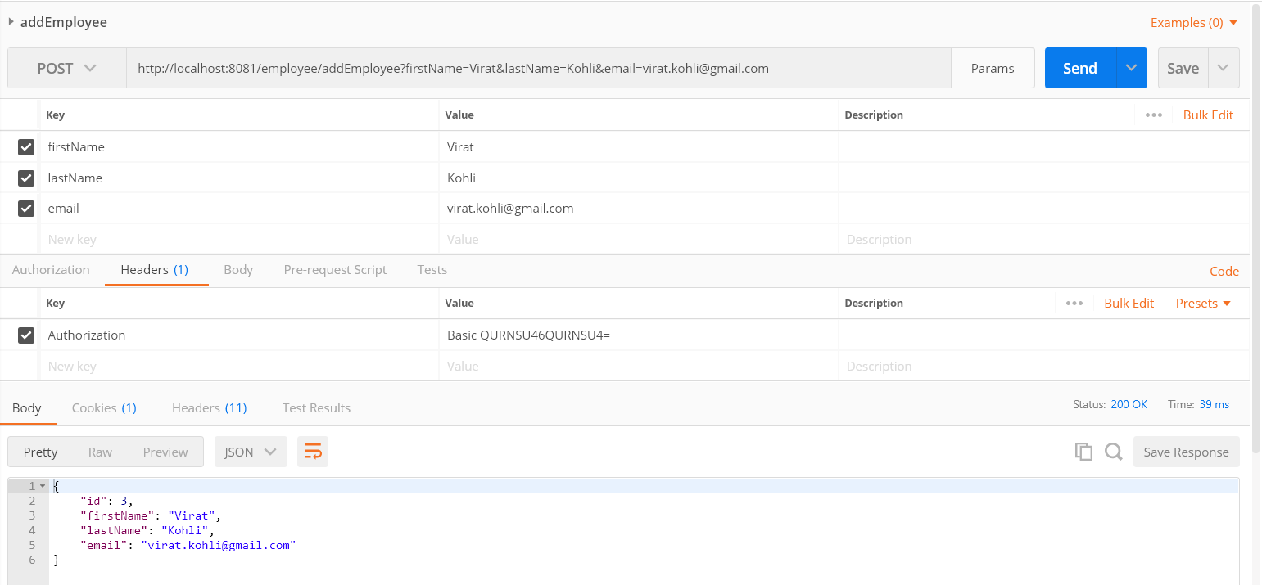

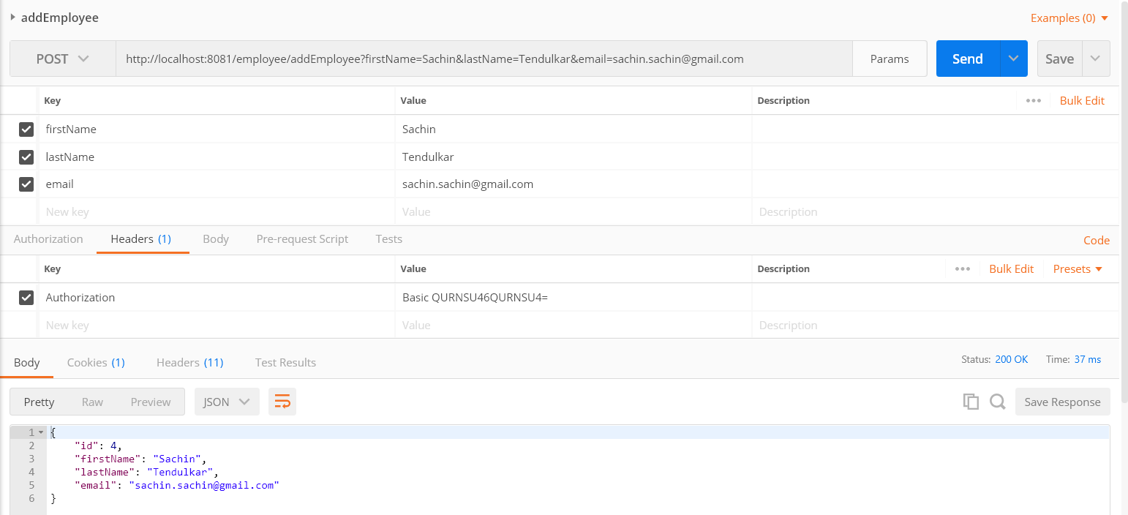

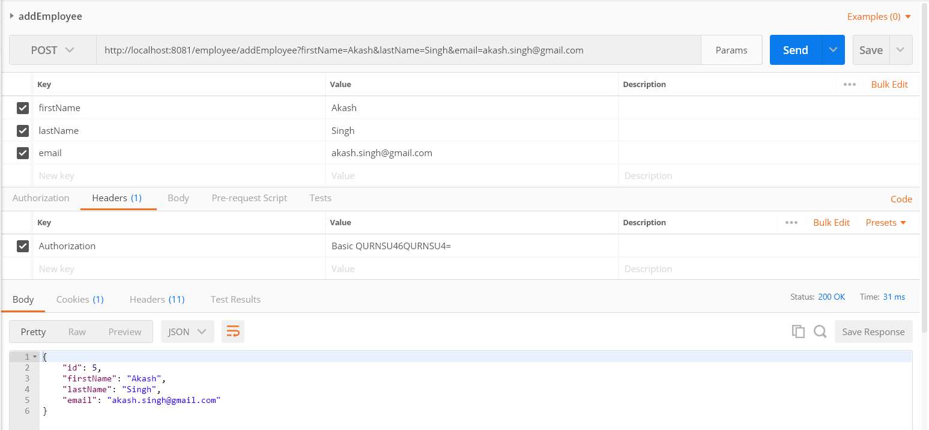

1. **Listing All Employees**

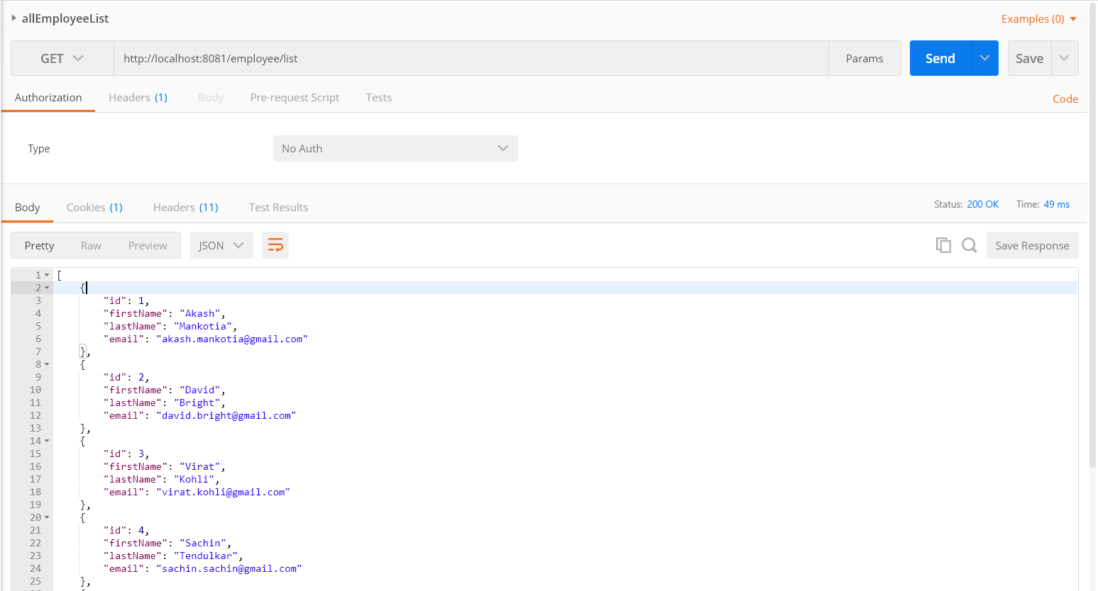



1. **Sorting Employees by first name in Ascending order**

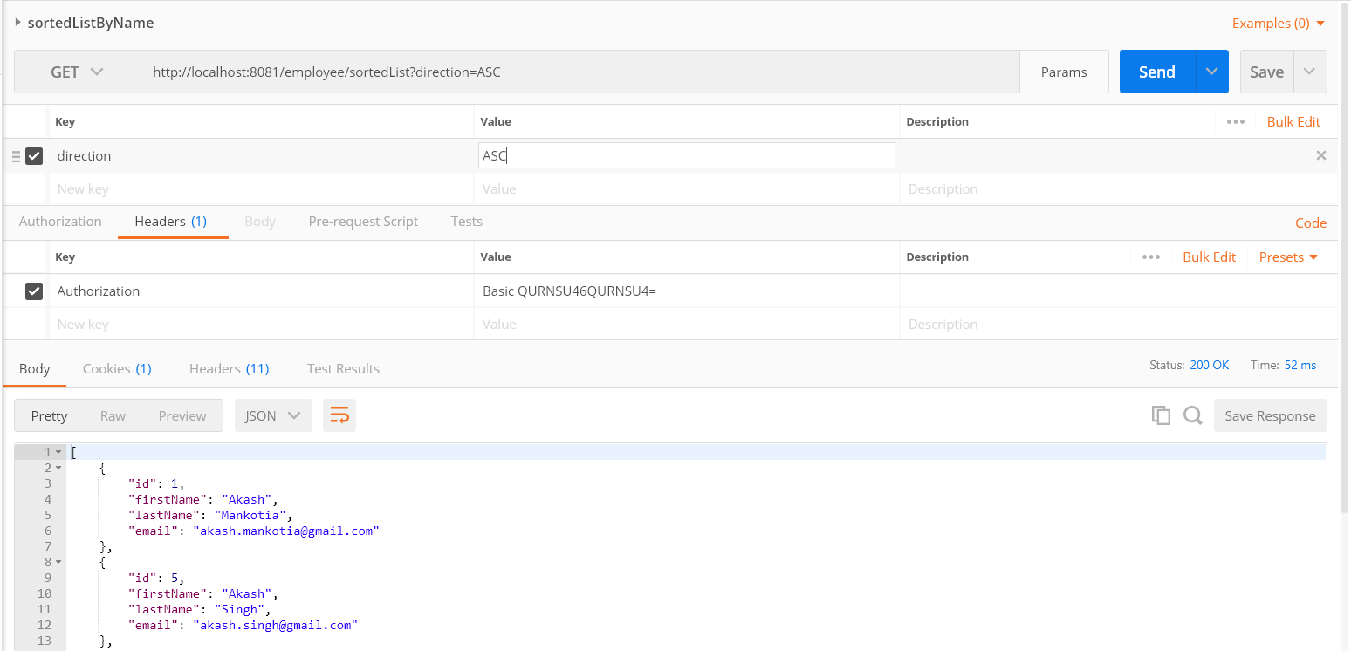

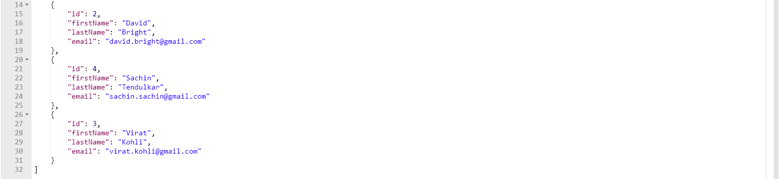

1. **Sorting Employees by first name in Descending order**

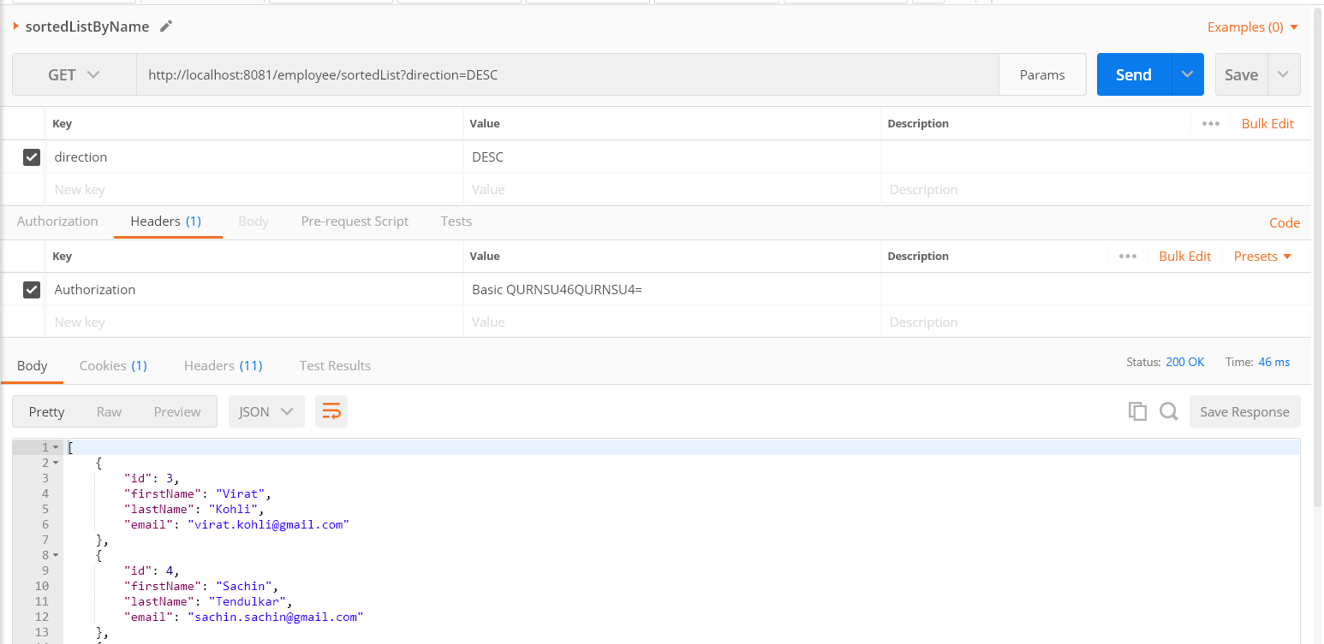

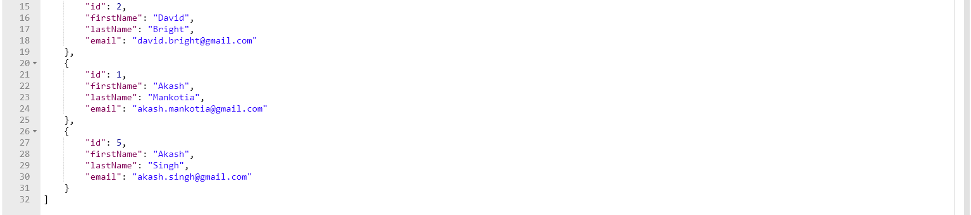

1. **Updating Employee Record**

{

"id": 4,

"firstName": "Sachin",

"lastName": "Tendulkar",

"email": "sachin.sachin@gmail.com"

}

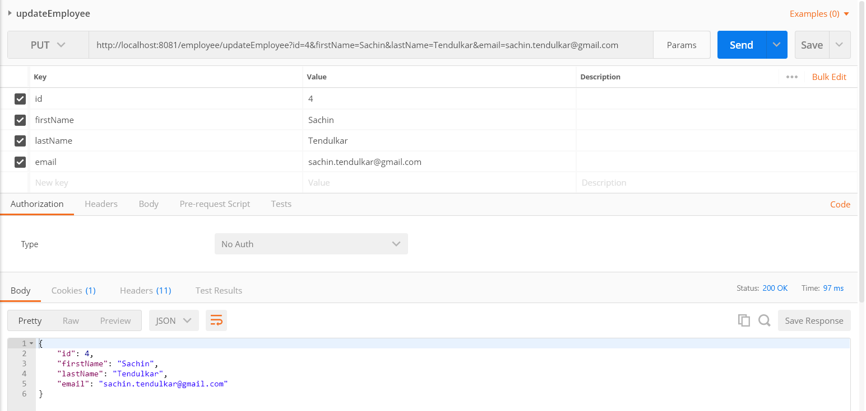

1. **Getting Employee by Id**

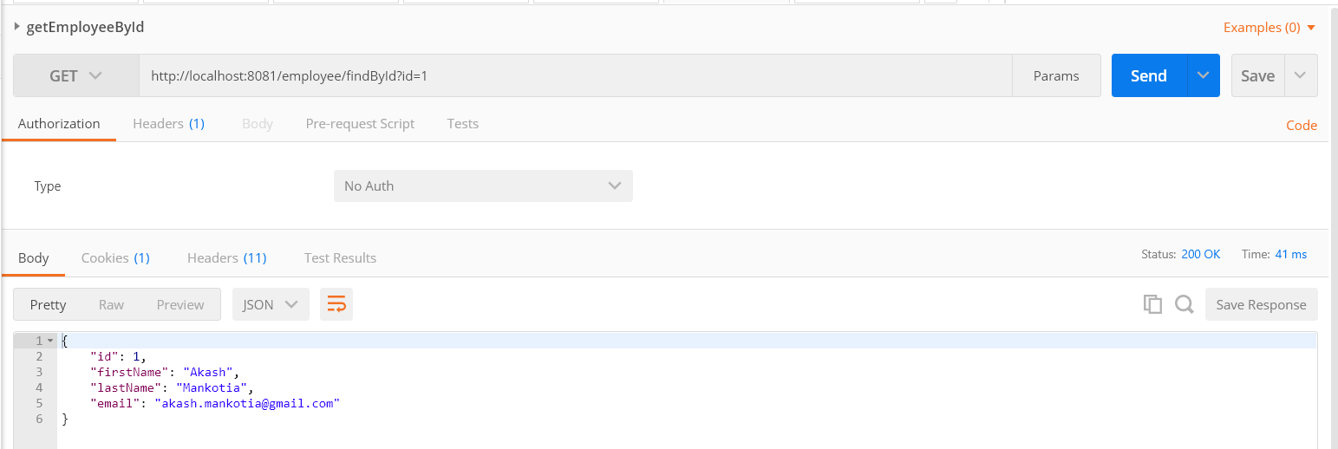

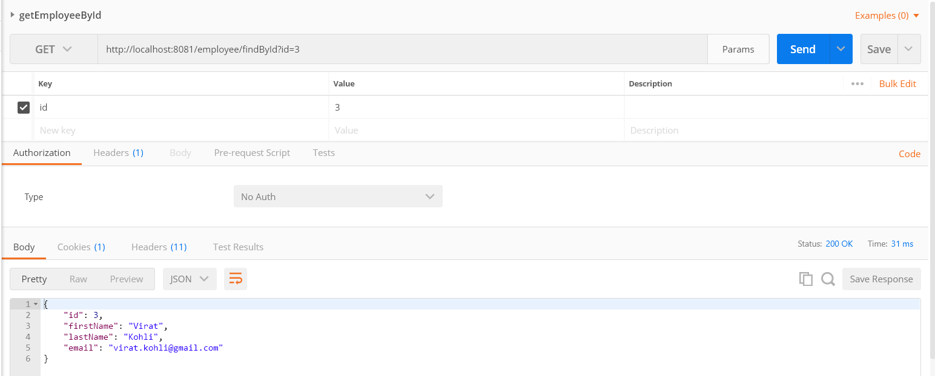

1. **Getting Employee details by first name**

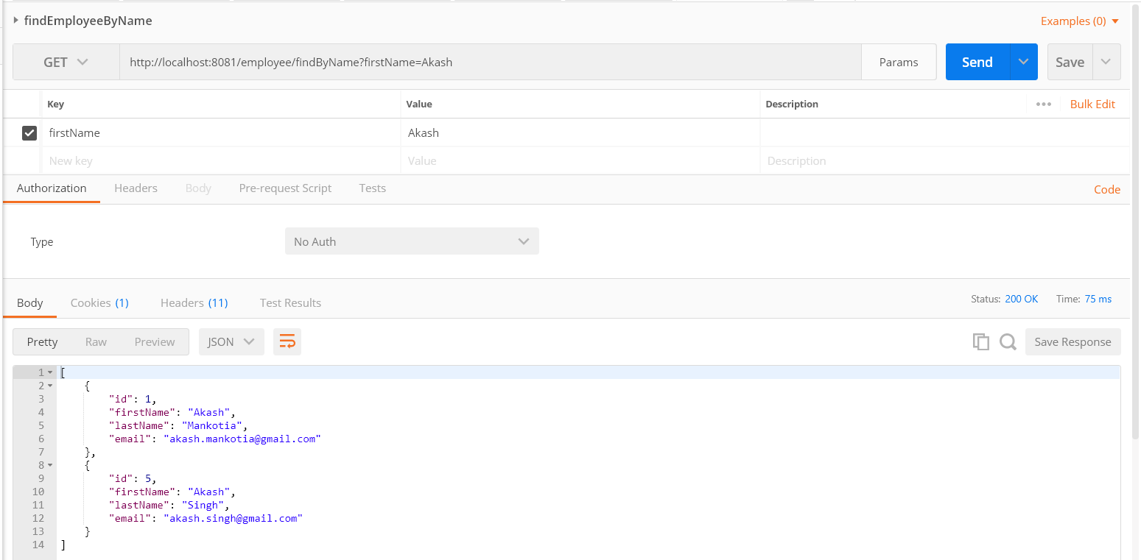

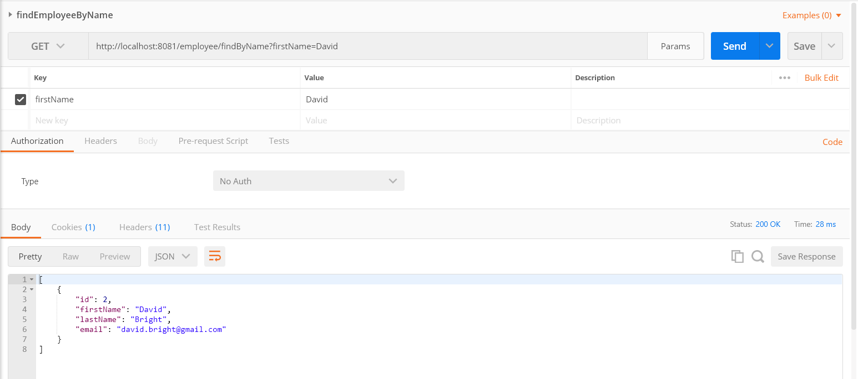

1. **Deleting Employee by Id**

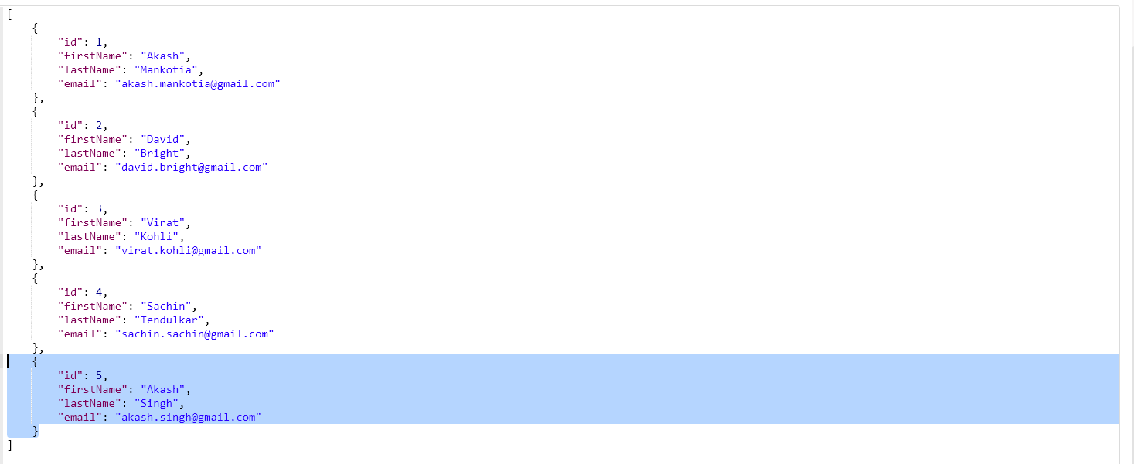

Deleting Employee by id 5

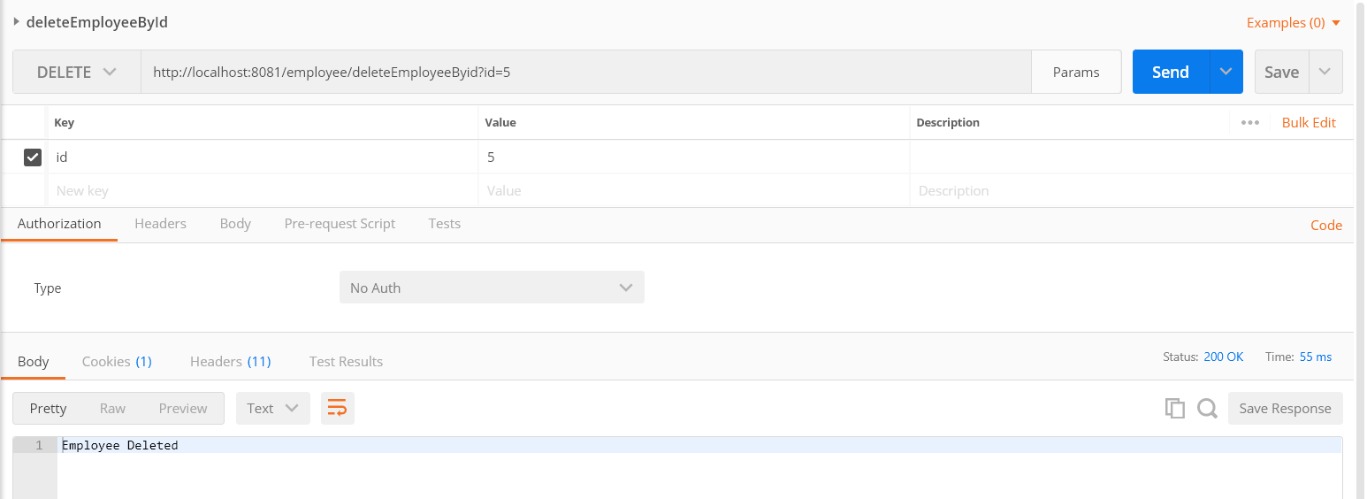

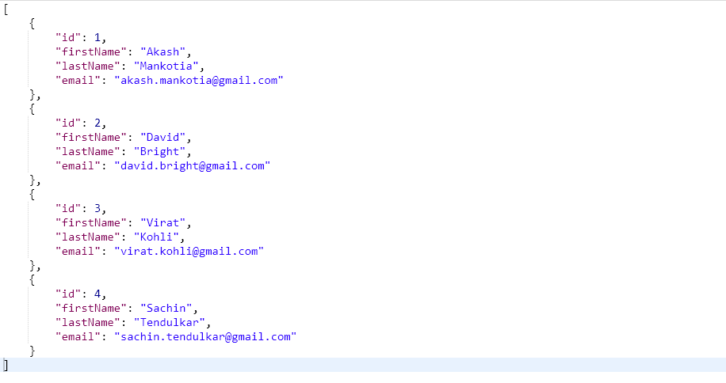

1. Logging out

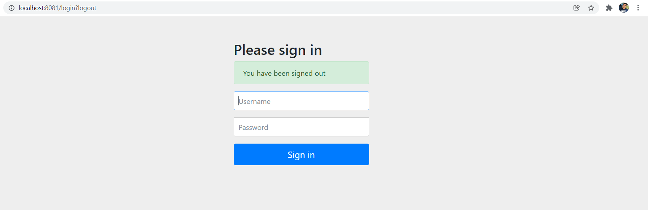

1. Login Form with User as ADMIN having Role as ADMIN

UserName: USER

Password: USER

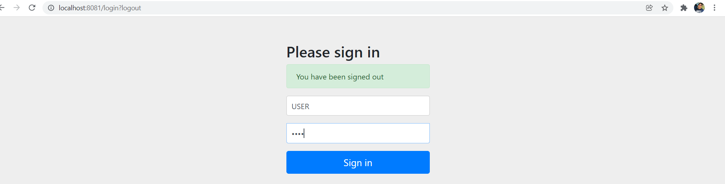

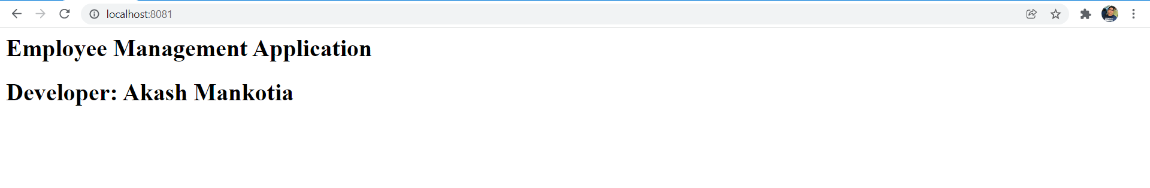

Note: This user has restricted access and cannot perform Add/Update/Delete operations

1. **Getting the List of Employees**

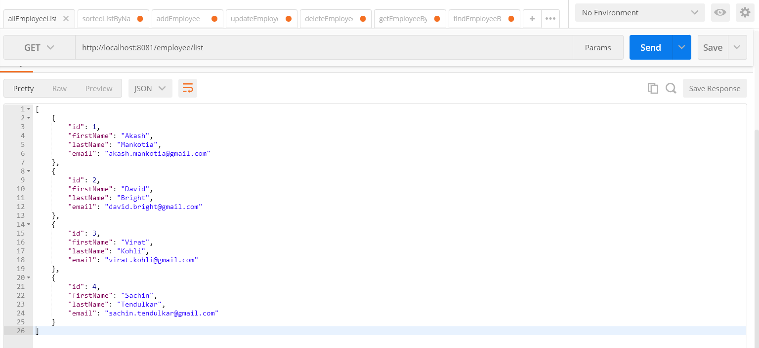

1. **Getting Employee by id**

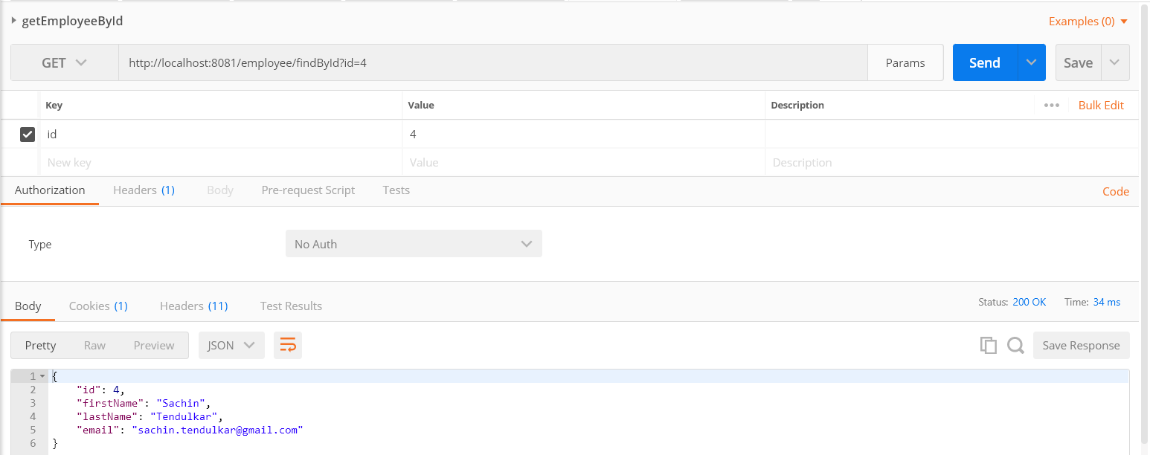

1. **Getting Employee by Name**

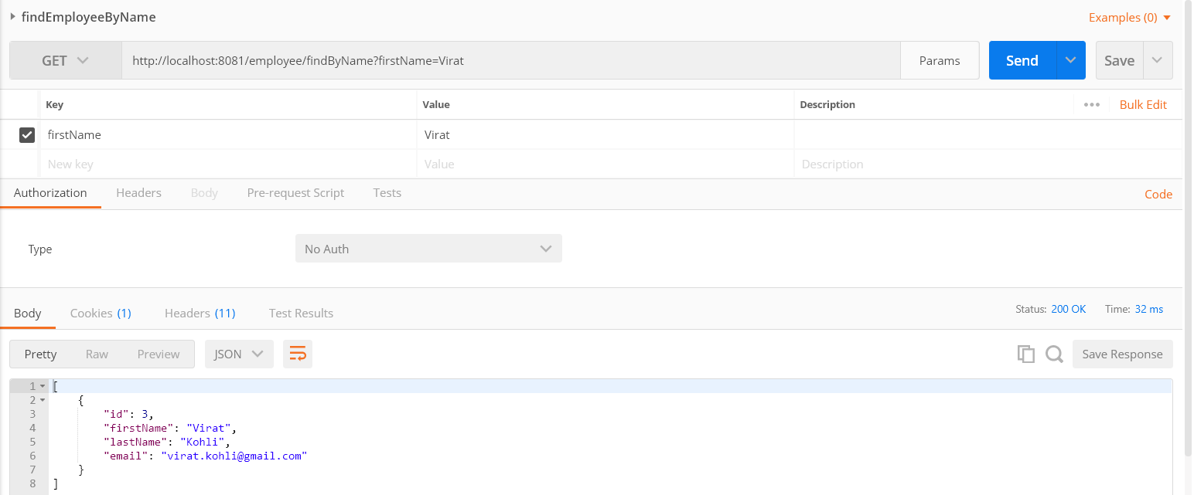

1. **Sort by first name in ascending order**

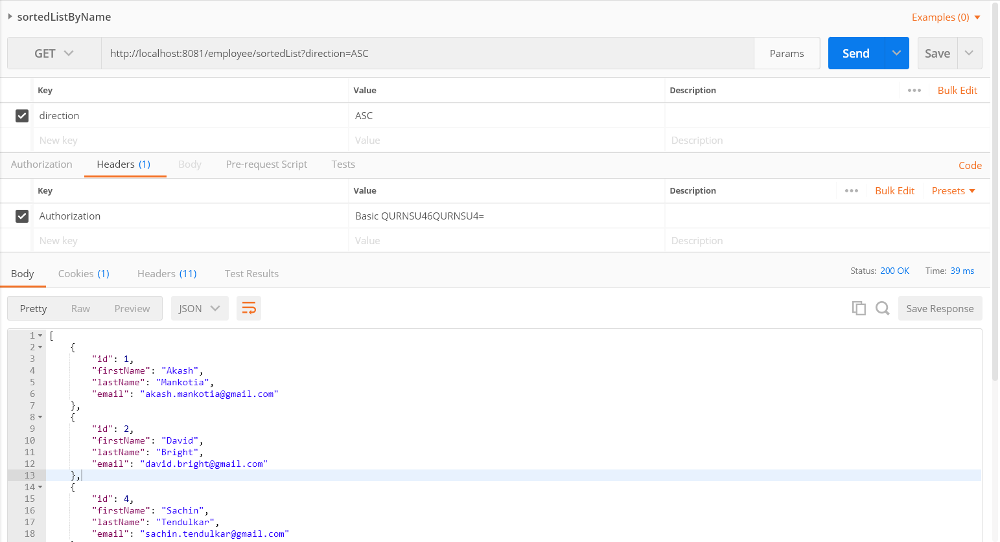

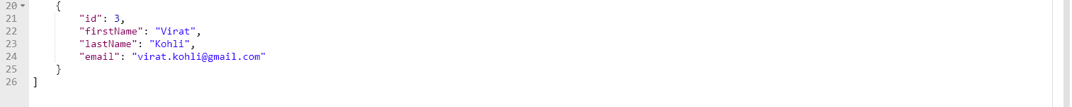

1. **Sort by first name in descending order**

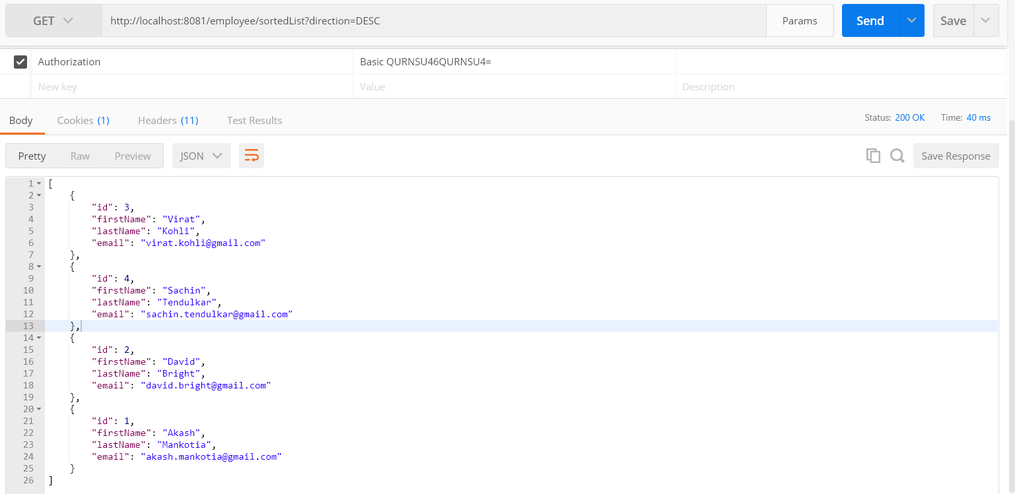

1. **Adding Employee – Forbidden for this user**

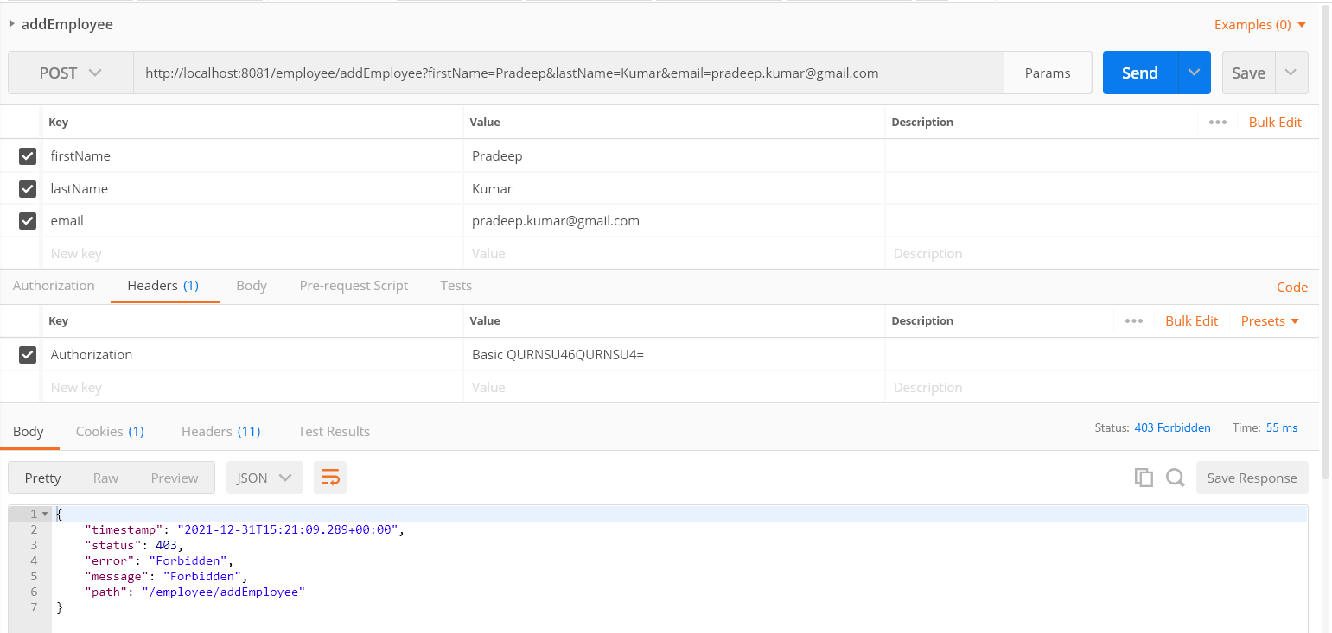

1. **Deleting employee – forbidden for this user**

Updating below record

{

"id": 2,

"firstName": "David",

"lastName": "Bright",

"email": "david.bright@gmail.com"

}

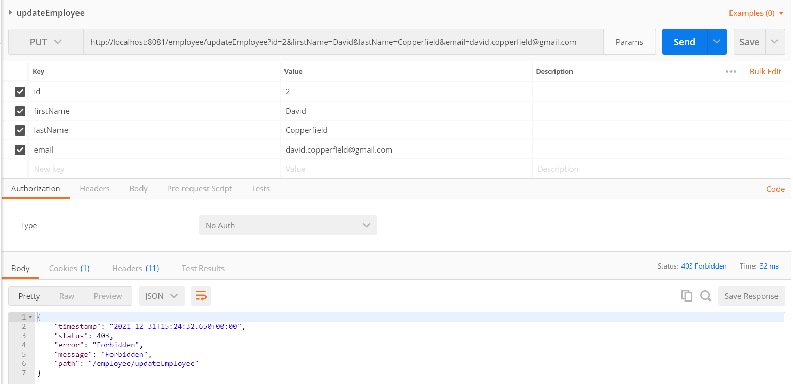

1. **Updating employee – forbidden for this user**

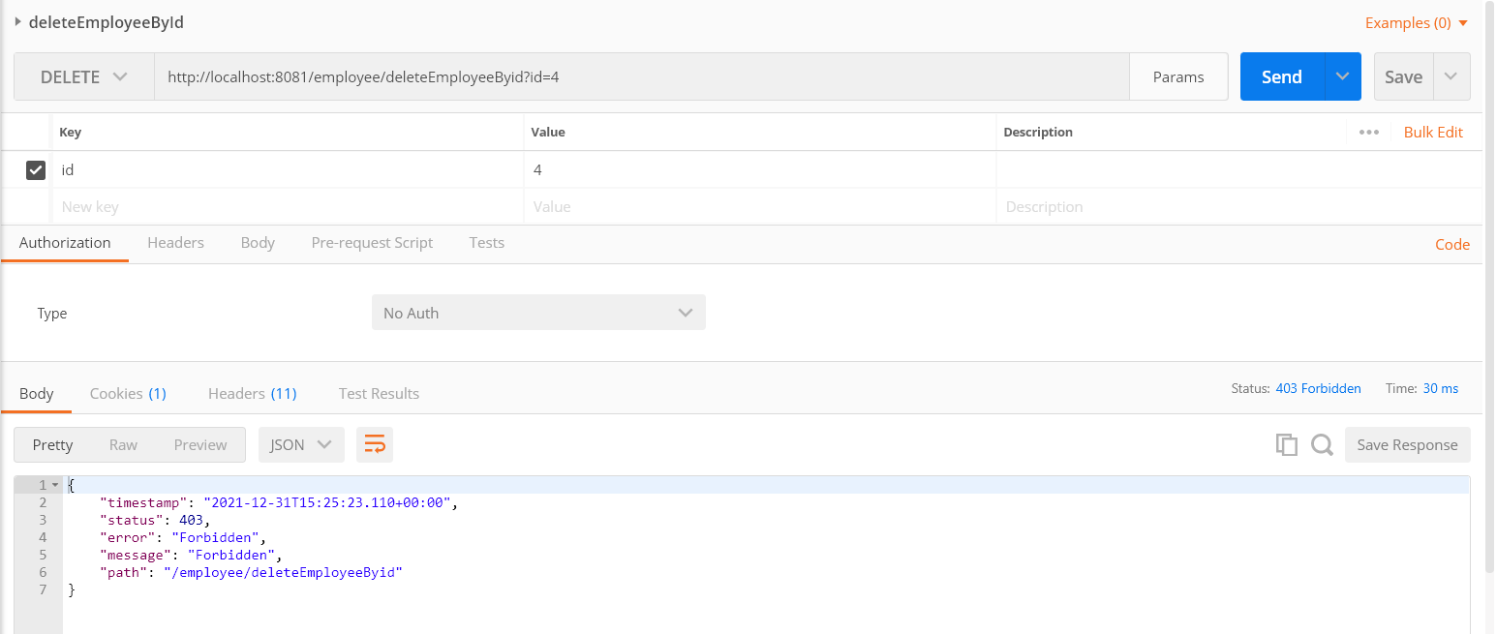

**Full API List in Swagger UI**

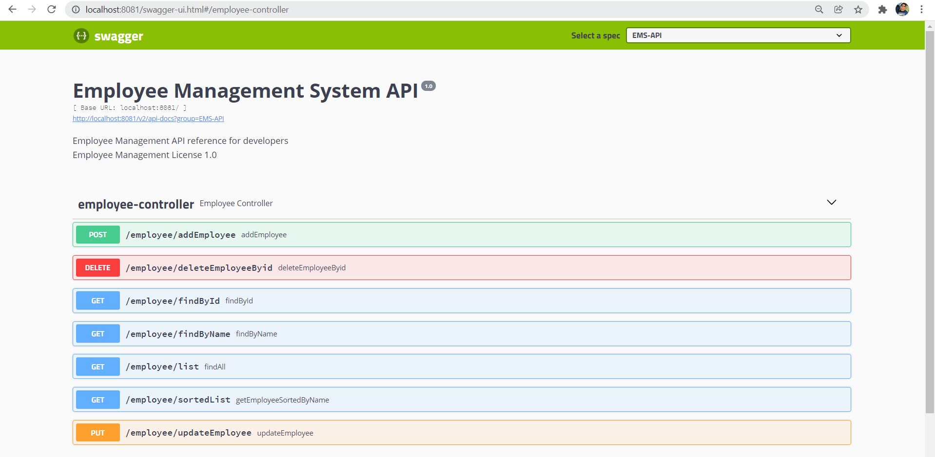

**H2-console screenshots**

